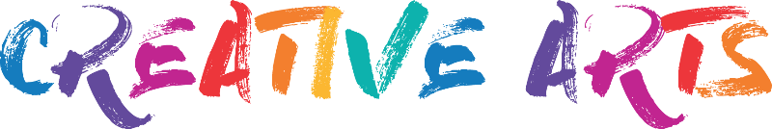

CREATIVE ARTS FAIR with RKM Global Fashion and AfriAus ILEAC:
Sign-up Form
Participant Information:
Full Name:
Email address:
Phone Number: [Your Phone Number/your parents phone number]

Please select the workshop(s) you wish to sign up for:
- Painting
- Basic Sewing Lessons
- Hand Crafts
- Drawing/Art

Workshop Dates: 27th, 28th and 29th December
Workshop times:
Morning session- 10:30am to 1:00pm
Lunch break- 1:00pm to 2:00pm (Lunch will be provided- as well as snacks)
Afternoon session- 2pm to 4:00pm

Please specify your Preferred date/s:
Please note that you can attend the workshops on all dates if you like or you can choose any day/s that is convenient for you

Emergency Contact Information
Emergency Contact Name:
Emergency Contact Phone:

Medical Information (if applicable):
Do you have any allergies or medical conditions we should be aware of? [Yes / No]
If "Yes," please provide details:

Dietary requirements
Do you have any special dietary requirements? Please specify below.

Terms and Conditions:
By submitting this form, I acknowledge that I have read and agree to the terms and conditions of the RKM Global Creative Arts Workshop in collaboration with AfriAus iLEAC and GilrForce Victoria. I also understand that photos will be taken of all the participants taking part in these workshops for the purpose of reports as well as publishing on the website of AfriAus iLEAC.

(please sign here if you agree)
------------------------------------------------------------
Please complete this form and send it to rkmglobalfashion@gmail.com . We will contact you to confirm your registration and provide further details about the workshop.
Thank you for your interest in the Craft Fair with RKM Global Fashion in collaboration with AfriAus iLEAC and GirlForce Victoria.
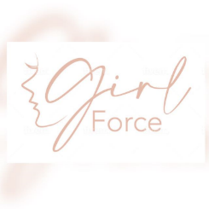
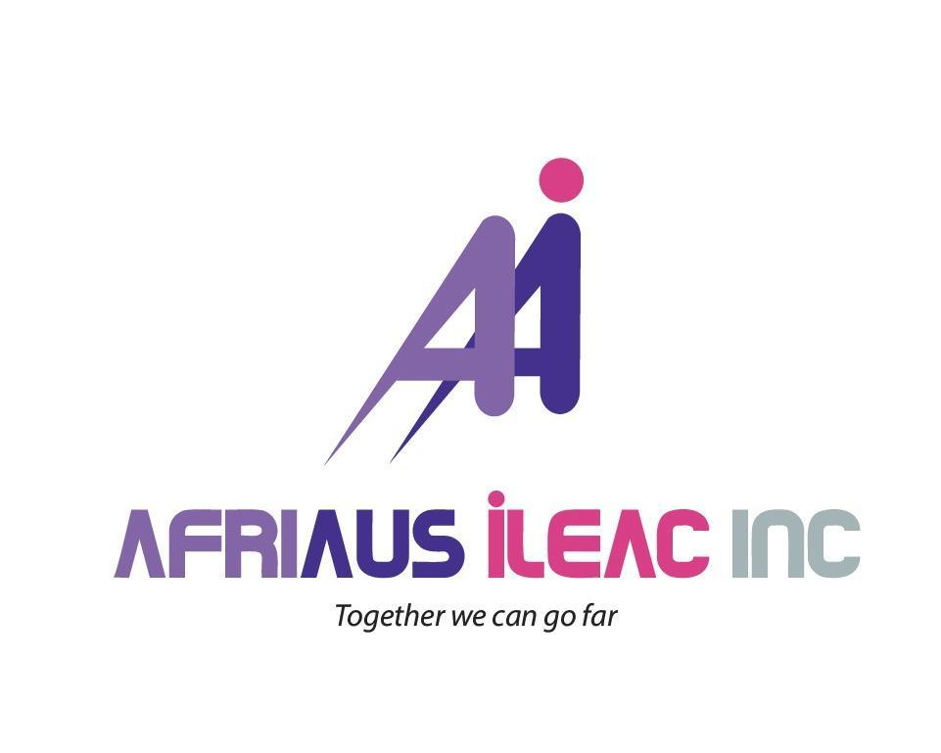
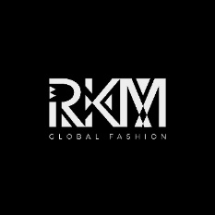

Supported by:
