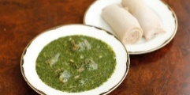
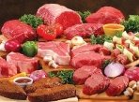
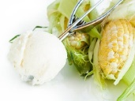
Date: __________________
FREE!
POP-UP FOOD MARKET CULTURALLY APPROPRIATE Luvpacks PRE-ORDERING FORM
PERSONAL DETAILS
Full name: |  |  | Gender: Male / Female / Other
Contact number: |  | Community/Organisation:
Preferred home street address:
Number of people in your family or household:
Pre-orders Preferred ID (tick, circle, underline or highlight your ID you will use when picking up your order) | Medicare card |  | Other (Specify):
 | Driver’s Licence
Email the completed form to info@afriausileac.org
ITEM (Healthy & Culturally Appropriate, where possible) | YES | NO
Jasmine/Basmati/Sunrise Rice - 5 kg (Select, pls)
Jasmine/Basmati/Sunrise Rice 10 kg (Select, pls)
White flour - 5 kg
Maize (Mealie/Corn, Ugali) flour – 5 kg
Semolina flour – 5 kg
Cassava flour (For Fufu)
Toilet paper
Cooking oil – 2 litres (Sunflower/Palm/Vegetable)
Cooking oil – 3+ litres (Sunflower/Palm/Vegetable)
Baby wipes
Baby nappies and size or baby’s weight (Size: 2, 3, 4, 5 or 6?)
Toothpaste – adult/children (Select, pls)
Tea bags
Salt
Sugar or Cocoa powder (Select, pls)
Dishwashing liquid
Laundry detergent
Greek yoghurt
Cereals –Wheatbix, Rice bubbles, Fruit loops (Select, pls)
Peanut butter
Full fresh milk
Full cream milk – Lactose free
Low fat milk
Body wash
Peanut butter
Dry beans
Lentils
Vegetables: Okra, Molokhia, onions, tomatoes, cucumber, carrot, pumpkin, eggplant (select, pls)
Frozen: taro, bananas, cassava, maize, yams, corn (Select, pls)
Halal meat (depends on availability)
Children’s: Chocolates, candies, ice cream – tbc, if available (Select, pls)
Irish or Sweet potatoes (Select, pls)
Insect/Mosquito repellent
Anchovy or Other food (Specify):

