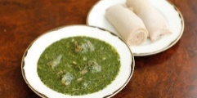
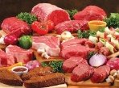
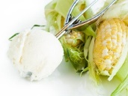
Date: __________________
FREE!
POP-UP FOOD MARKET CULTURALLY APPROPRIATE Luvpacks PRE-ORDERING FORM
PERSONAL DETAILS
Full name: |  |  | Gender: Male / Female / Other
Contact number: |  | Community/Organisation:
Preferred home street address:
Number of people in your family or household:
Pre-orders Preferred ID (tick, circle, underline or highlight your ID you will use when picking up your order) | Medicare card |  | Other (Specify):
 | Driver’s Licence
Email the completed form to info@afriausileac.org
ITEM (Healthy & Culturally Appropriate, where possible) | YES | NO
Jasmine/Basmati/Sunrise Rice - 5 kg (Select, pls)
Jasmine/Basmati/Sunrise Rice 10 kg (Select, pls)
White flour - 5 kg
Maize (Mealie/Corn, Ugali) flour – 5 kg
Semolina flour – 5 kg
Cassava flour (For Fufu)
Cooking oil – 2 litres (Sunrise/Palm/Vegetable) – Select, pls
Cooking oil – 3+ litres (Sunrise/Palm/Vegetable) – Select, pls
Tea bags
Salt
Sugar or Cocoa powder (Select, pls)
Greek yoghurt
Cereals –Wheatbix, Rice bubbles, Fruit loops (Select, pls)
Peanut butter
Full fresh milk
Full cream milk – Lactose free
Low fat milk
Dry beans
Lentils
Vegetables: Okra, Molokhia, onions, tomatoes, cucumber, carrot, pumpkin, eggplant (select, pls)
Frozen: taro, bananas, cassava, maize, yams, corn (Select, pls)
Halal meat (depends on availability)
Children’s: Chocolates, candies, ice cream – tbc, if available (Select, pls)
Irish or Sweet potatoes (Select, pls)
Insect/Mosquito repellent
Anchovy or Other food (Specify):

